

12/25/2021

**Department Of Computer Science**

**Subject** **Instructor:** Dr Moiz Ullah **Assignment:** 3 **Date:** 25-12-2021 **Class:** BSCS-3B

**Submitted by:**

Madina Javed Iqbal Khokhar 2426

Amara 2410

Aneeba Shezadi 2418

**Task**

**Write a survey report on “Graph coloring, its types and Application areas”. It should contain the definition, the types and the areas where graph coloring can be applied to solve real-world problems.**

**Terminologies:**

* **Graph:**

A graph is a set of vertices V coupled with a set of edges E, each edge being incident on a pair of vertices in V.

* **Sub Graph:**

Subgraph of a graph is a subset of V , called V ‘ , coupled with a subset of E, called E’ , such that each edge in E’ is incident on two vertices in V’.

* **Degree:**

The degree of a vertex v is the number of edges that are incident on v.

* **Chromatic Number:**

The **chromatic number**of a graph is the minimum number of colors for which such an assignment is possible.

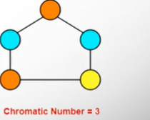

Minimum number of color to required to properly colored the vertices are three. So, chromatic number is 3.

**Vertex Coloring:**

A proper vertex coloring problem for a graph is to color all the vertices of the graph with different colors in such a way that any two adjacent (having an edge connecting them) vertices of assigned different colors.

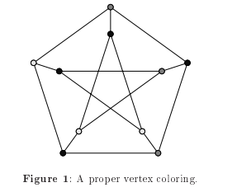

**Graph Coloring**

Graph coloring is one of the best known, popular and extensively researched subject in the field of graph theory, having many applications and conjectures, which are still open and studied by various mathematicians and computer scientists along the world. In this assignment, we will discuss a graph coloring theory, describing various methods of the coloring, and a list of problems , conjectures associated with them and its applications to solve real world problems.

**Definition:**

A **graph coloring** is an assignment of labels called colors, to the vertices of a graph such that no two adjacent vertices share the same color.

**Properly Colored Graph:**

A proper coloring is an assignment of colors to the vertices of a graph so that no two adjacent vertices have the same color. For instance, in the given below graph, no two adjacent vertices are colored with the same color. Therefore, it is properly colored graph.

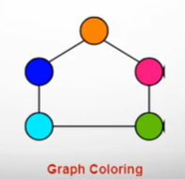

**Types of Graph Coloring**

**Circular Coloring:**

In this type of coloring we are allowed to assign fractional numbers, not only integers, to vertices, and values of adjacent vertices need to fall within a certain range (having specified minimum difference, and the maximum value assigned to a vertex).

**Edge coloring:**

The other well-known and intensely studied type of graph coloring besides vertex coloring is the edge coloring. Analogically to the definition of the vertex coloring, the edge coloring of a graph G = (V, E) is a mapping, which assigns a color to every edge, satisfying condition that no two edges sharing a common vertex have the same color.

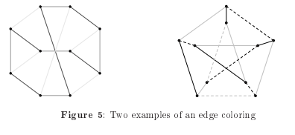

**Face Coloring:**

The face coloring is the method used to color areas on a political map, and so it is the coloring associated with the Four Color theorem. This type of coloring requires a graph to be planar, what means the graph can be drawn on a 2-dimensional plane without intersections between edges.

**Map Coloring:**

A map coloring can be done by creating the dual graph, in which every vertex represents one face of the map (including the outermost face), and any two vertices are connected if and only if faces represented by them are adjacent.

**Path coloring:**

A path coloring of a graph is a specific type of edge coloring. Here, we need to color certain paths linking some certain pairs of vertices, and where each path contains a specific set of edges, satisfying the condition that no two paths containing the same edge (or in some versions of the path coloring it is required for the same-color paths to pass through disjoint sets of vertices) of the graph or multigraph (depending on the problem to solve there may be several edges connecting the same vertices).

**Total coloring:**

In the total coloring of a graph, vertices and edges are colored simultaneously. Every two adjacent vertices, any two edges having a common vertex, as well as every incident pair (vertex, edge) must be assigned different colors.

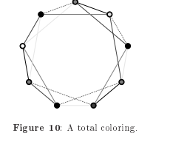

**Theorem 4 (Four Color Theorem):**

The four-color theorem states that any map in a plane can be colored using four-colors in such a way that regions sharing a common boundary (other than a single point) do not share the same color.

**Theorem 5 (Six Color Theorem):**

Any map can be colored with six or fewer colors in such a way that no adjacent territories receive the same color.

**Theorem 6 (Five Color Theorem):**

Any map can be colored with five or fewer colors in such a way that no adjacent territories receive the same color.

**Applications of Graph Coloring**

[**Mobile Radio Frequency Assignment**](http://www.zib.de/groetschel/teaching/SS2012/GraphCol%20and%20FrequAssignment.pdf)**:**

 When frequencies are assigned to towers, frequencies assigned to all towers at the same location must be different. How to assign frequencies with this constraint? What is the minimum number of frequencies needed? This problem is also an instance of graph coloring problem where every tower represents a vertex and an edge between two towers represents that they are in range of each other.

**Bipartite Graphs:**

We can check if a graph is Bipartite or not by coloring the graph using two colors. If a given graph is 2-colorable, then it is Bipartite, otherwise not.

**Sudoko:**

Each row, column, or block of the Sudoku puzzle forms a clique in the Sudoku graph, whose size equals the number of symbols used to solve the puzzle. A graph coloring of the Sudoku graph using this number of colors (the minimum possible number of colors for this graph) can be interpreted as a solution to the puzzle.

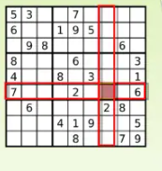

**Map Coloring:**

Geographical maps of countries or states where no two adjacent cities cannot be assigned same color. Four colors are sufficient to color any map (four color theorem).

**Student Time Table:**

Graph Coloring Algorithm is used to generate the student weekly time table in a typical university department. The problem is a Node-Point problem and it could not be solved in the polynomial domain. Various constraints in weekly scheduling such as lecturer demands, course hours and laboratory allocations were confronted and weekly time tables were generated for 1st, 2nd, 3rd and 4th year students in a typical semester.

In a typical semester, the courses are required to be scheduled at different times in order to avoid conflict. The problem of determining the minimum number (or a reasonable number) of time slots needed to schedule all the courses subject to restrictions is a graph coloring problem. Given below figure illustrates a simple timetabling problem instance in which we have five courses to be scheduled: Physics, Calculus, Electronics, Microprocessors, and Operating Systems.

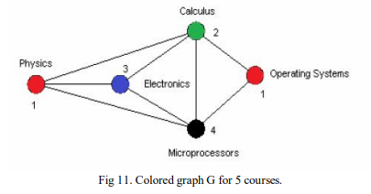

**Aircraft Scheduling:**

Assume that we have k aircrafts, and we have to assign them to n flights, where the ith flight is during the time interval (ai, bi). Clearly, if two flights overlap, then we cannot assign the same aircraft to both flights. The vertices of the conflict graph correspond to the flights, two vertices are connected if the corresponding time intervals overlap. Therefore the conflict graph is an interval graph, which can be colored optimally in polynomial time.

***THANKS***